- Download XAMPP (Project use PHP v8)

Link download: <https://www.apachefriends.org/download.html>

- Download and install Composer (latest version)

Link download: <https://getcomposer.org/download/>

**\* Lưu ý cài đặt XAMPP trước Composer để tránh xảy ra lỗi**

- After downloading the .rar project file, proceed to extract it in Disk(C,D,..):\xampp\htdocs

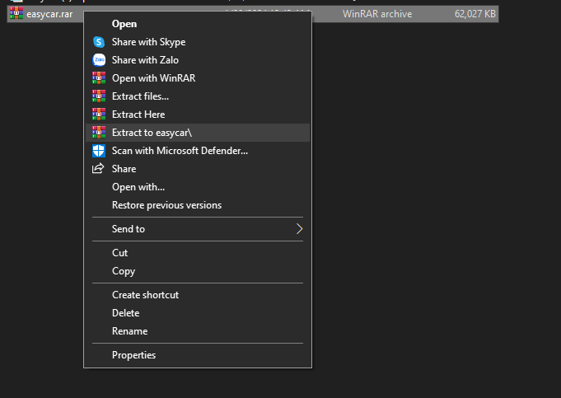

- Override Ctrl + Right click on the extracted project folder and select "Open Git Bash Here"

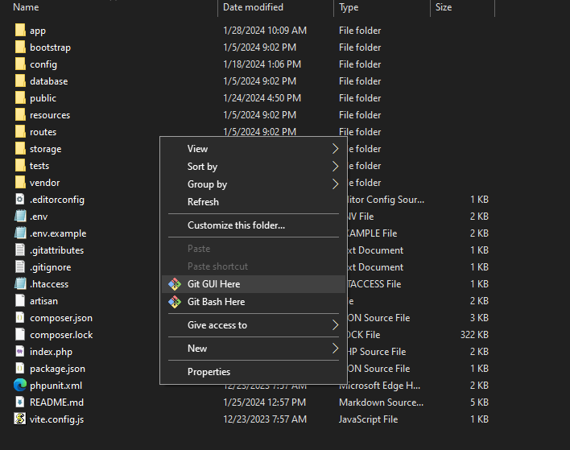

- In the Git Bash window, type the following commands one by one

1. **“composer update”**



2. **”composer dumpautoload”**



- The project uses phpmySQL server, so it needs a server containing a database named "easycar" for you to test run the project.

Here I use XAMPP to create a local server (you can use other software)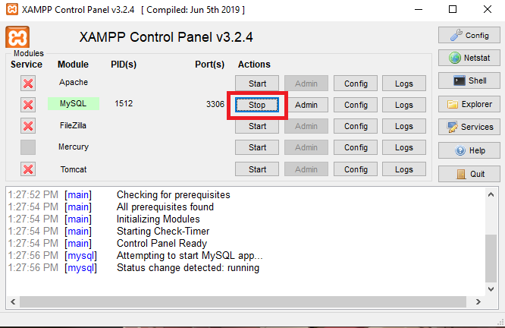

- Proceed to create a database named “easycar” on your local phpmysql server. Here I use the DBever interface to create the database (you can use other software)

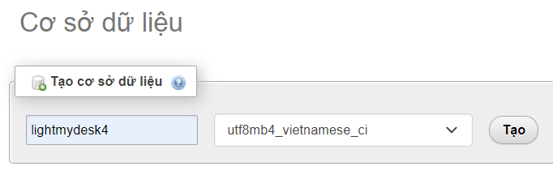

Import data from file easycar.sql to “easycar” database

1. **“set in config select database.php”**

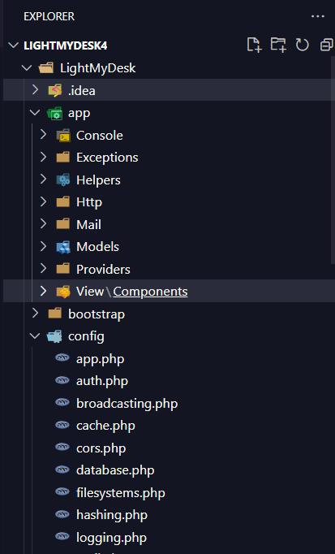

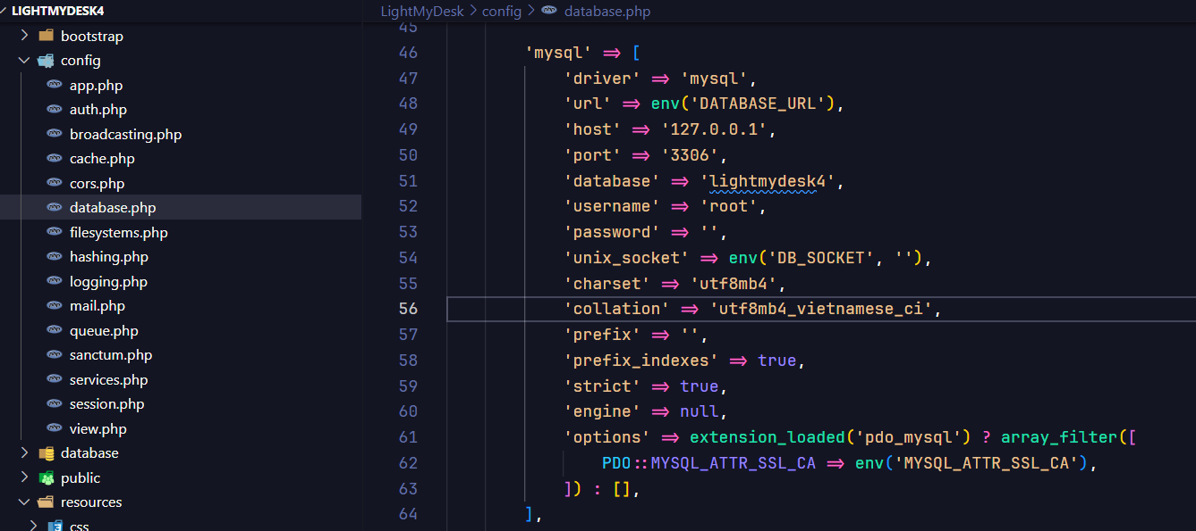

Then go to the browser and click: localhost/lightmydesk/ (localhost:: depends on xampp por)

- Image of successful project test run